CHAPTER 5: Ecosystems — flow of energy and matter
Worksheet 5.2

Estimating the size of a population
Science Quest 9: pages 183–8
Answers

Population of nettles in a paddock
1. A paddock has been invaded by stinging nettles. The quadrat method was used to estimate the population of nettles. A 100 m by 100 m area was divided into 100 smaller quadrats. Each quadrat measured 10 m by 10 m. The number of nettles in 15 of these random quadrats was measured. The results are shown in the table below.
Quadrat number | 1 | 2 | 3 | 4 | 5 | 6 | 7 | 8 | 9 | 10 | 11 | 12 | 13 | 14 | 15
Number of nettles | 4 | 6 | 3 | 2 | 0 | 4 | 2 | 3 | 1 | 4 | 4 | 2 | 3 | 1 | 6
(a) Calculate the average number of nettles per quadrat.
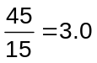

(b) Calculate the total area investigated.
100 × 100 = 10 000 m²

(c) Calculate the abundance of nettles in the whole paddock by using the formula:
Total number =  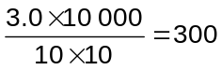 | average number per quadrat × total area
 | area of quadrat

(d) Estimate the density of nettles in the paddock by dividing your answer to part (c) by the total area in square metres.
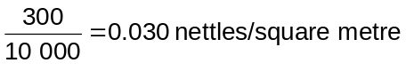

Capture–recapture
2. A biologist captures 14 goannas in a 10 square kilometre area of open woodland. He tags them and releases them back into the woodland. Six months later he returns and captures 10 goannas of which 7 have tags. Estimate the total population of goannas in that area using the following formula:
Total number = | number of animals on first visit × 100
Total number = | average percentage of tagged animals per recapture
